SEBI-CSCRF Compliance for Log360
Ensure operational resilience and SEBI-CSCRF compliance with Log360.
Region: India | Type: Incident Management, Operational Resilience | Category: Compliance | Pricing: Free

Overview
The SEBI-CSCRF compliance extension in Log360 helps organizations meet the SEBI Cybersecurity and Cyber Resilience Framework (CSCRF, August 2024), India's mandatory framework for all SEBI-regulated entities built on five resiliency goals measured by a Cyber Capability Index by providing centralized log management, real-time threat detection, and incident response support. The platform supports SEBI-CSCRF requirements for risk anticipation, identity and access management, network protection, threat containment, incident response, business continuity and disaster recovery, continuous monitoring, and governance.
To address Withstand — Identity and Access Management, the platform monitors AD logon, Windows and Unix authentication, SUDO commands, and MFA events. The extension also supports Withstand — Network and System Protection by providing capabilities that monitors network device rules, firewall security events, policy changes, network attacks, and device configuration modifications.

Key Features
- Contain — Threat Detection and Incident Response: Log360 correlates Windows and Unix threat detection, FireEye, Trend Micro, antivirus, Entra ID risky sign-ins, and network attack reports for rapid containment.
- Recover — Business Continuity and Disaster Recovery: Log360 monitors backup and disaster recovery infrastructure, job status, malware detection, IAM events, and Windows restore activities to validate continuity readiness.
- Evolve — Continuous Monitoring and Audit: Log360 centralizes EventLog, GPO auditing, system events, policy changes, database audit, and user auditing records for ongoing compliance review.
- Governance and Cyber Capability Index: Log360 tracks password policy compliance, user and group auditing, GPO changes, and policy modifications to demonstrate governance maturity.


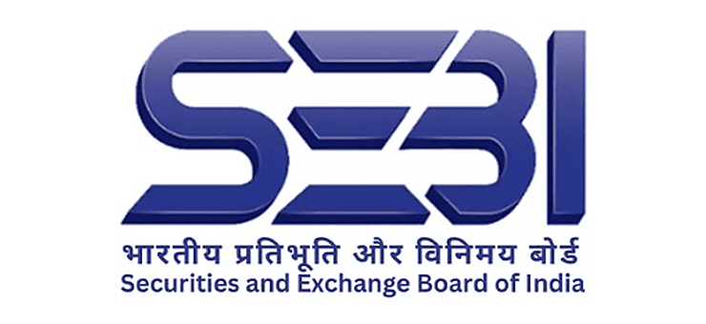

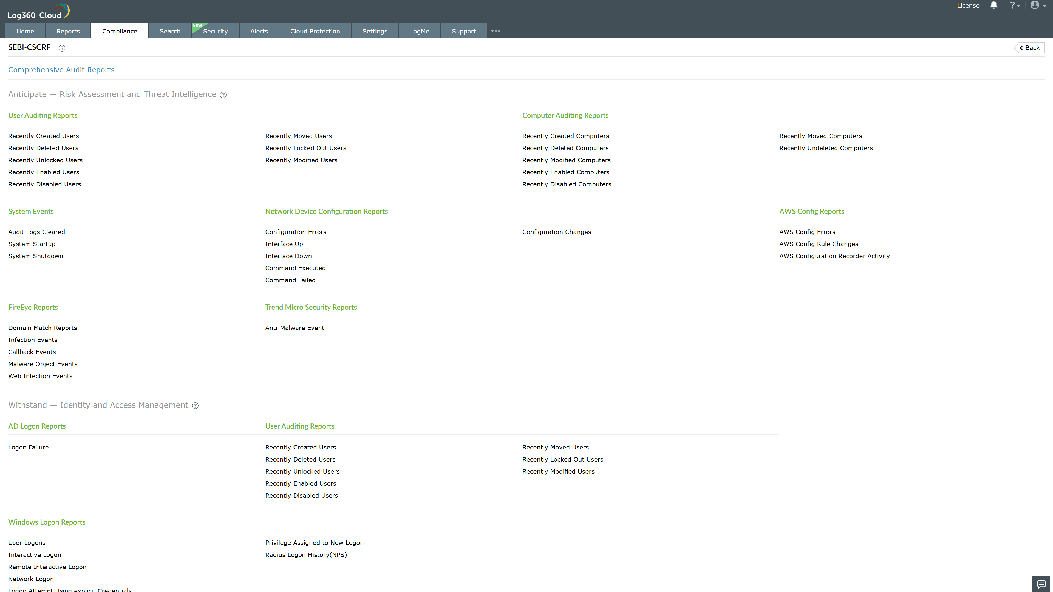
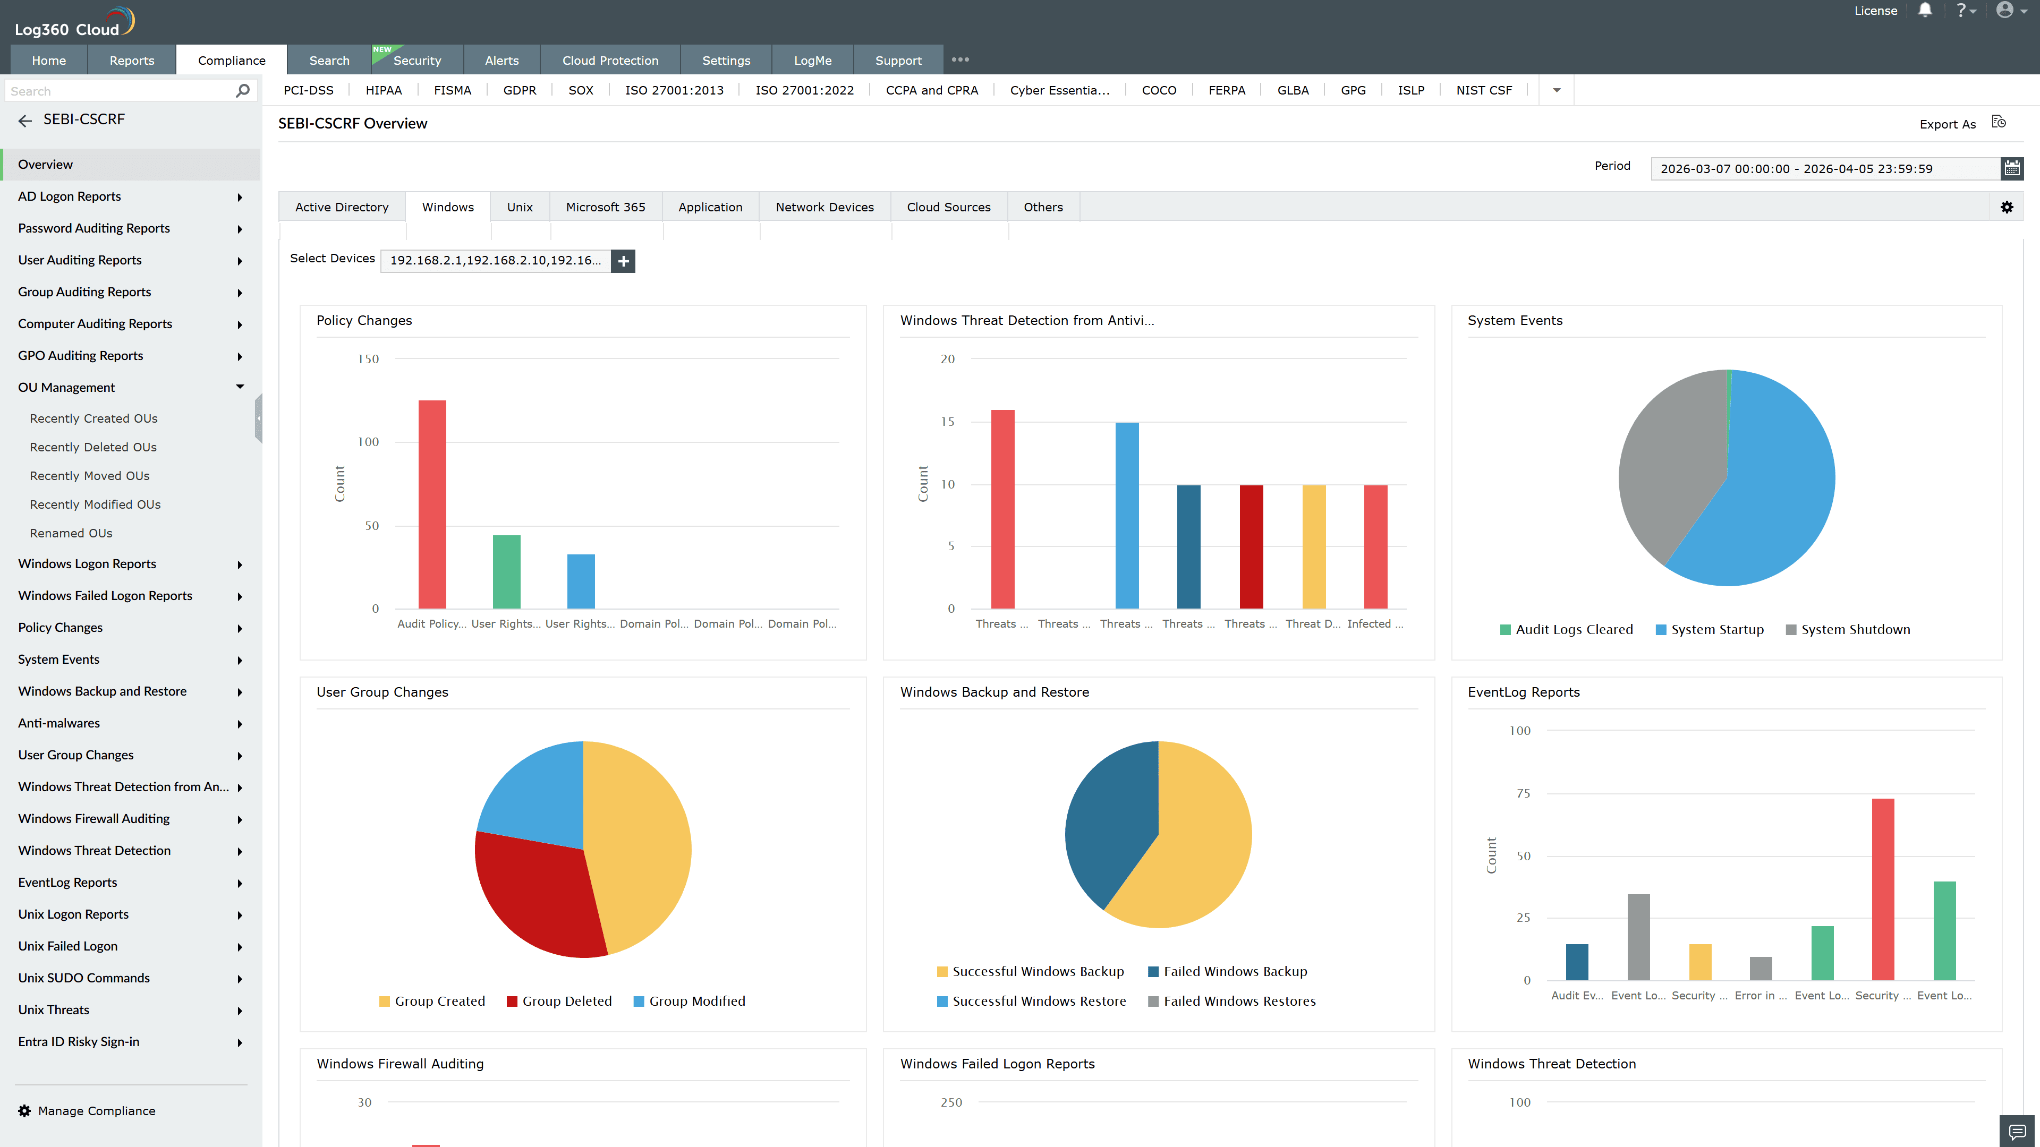
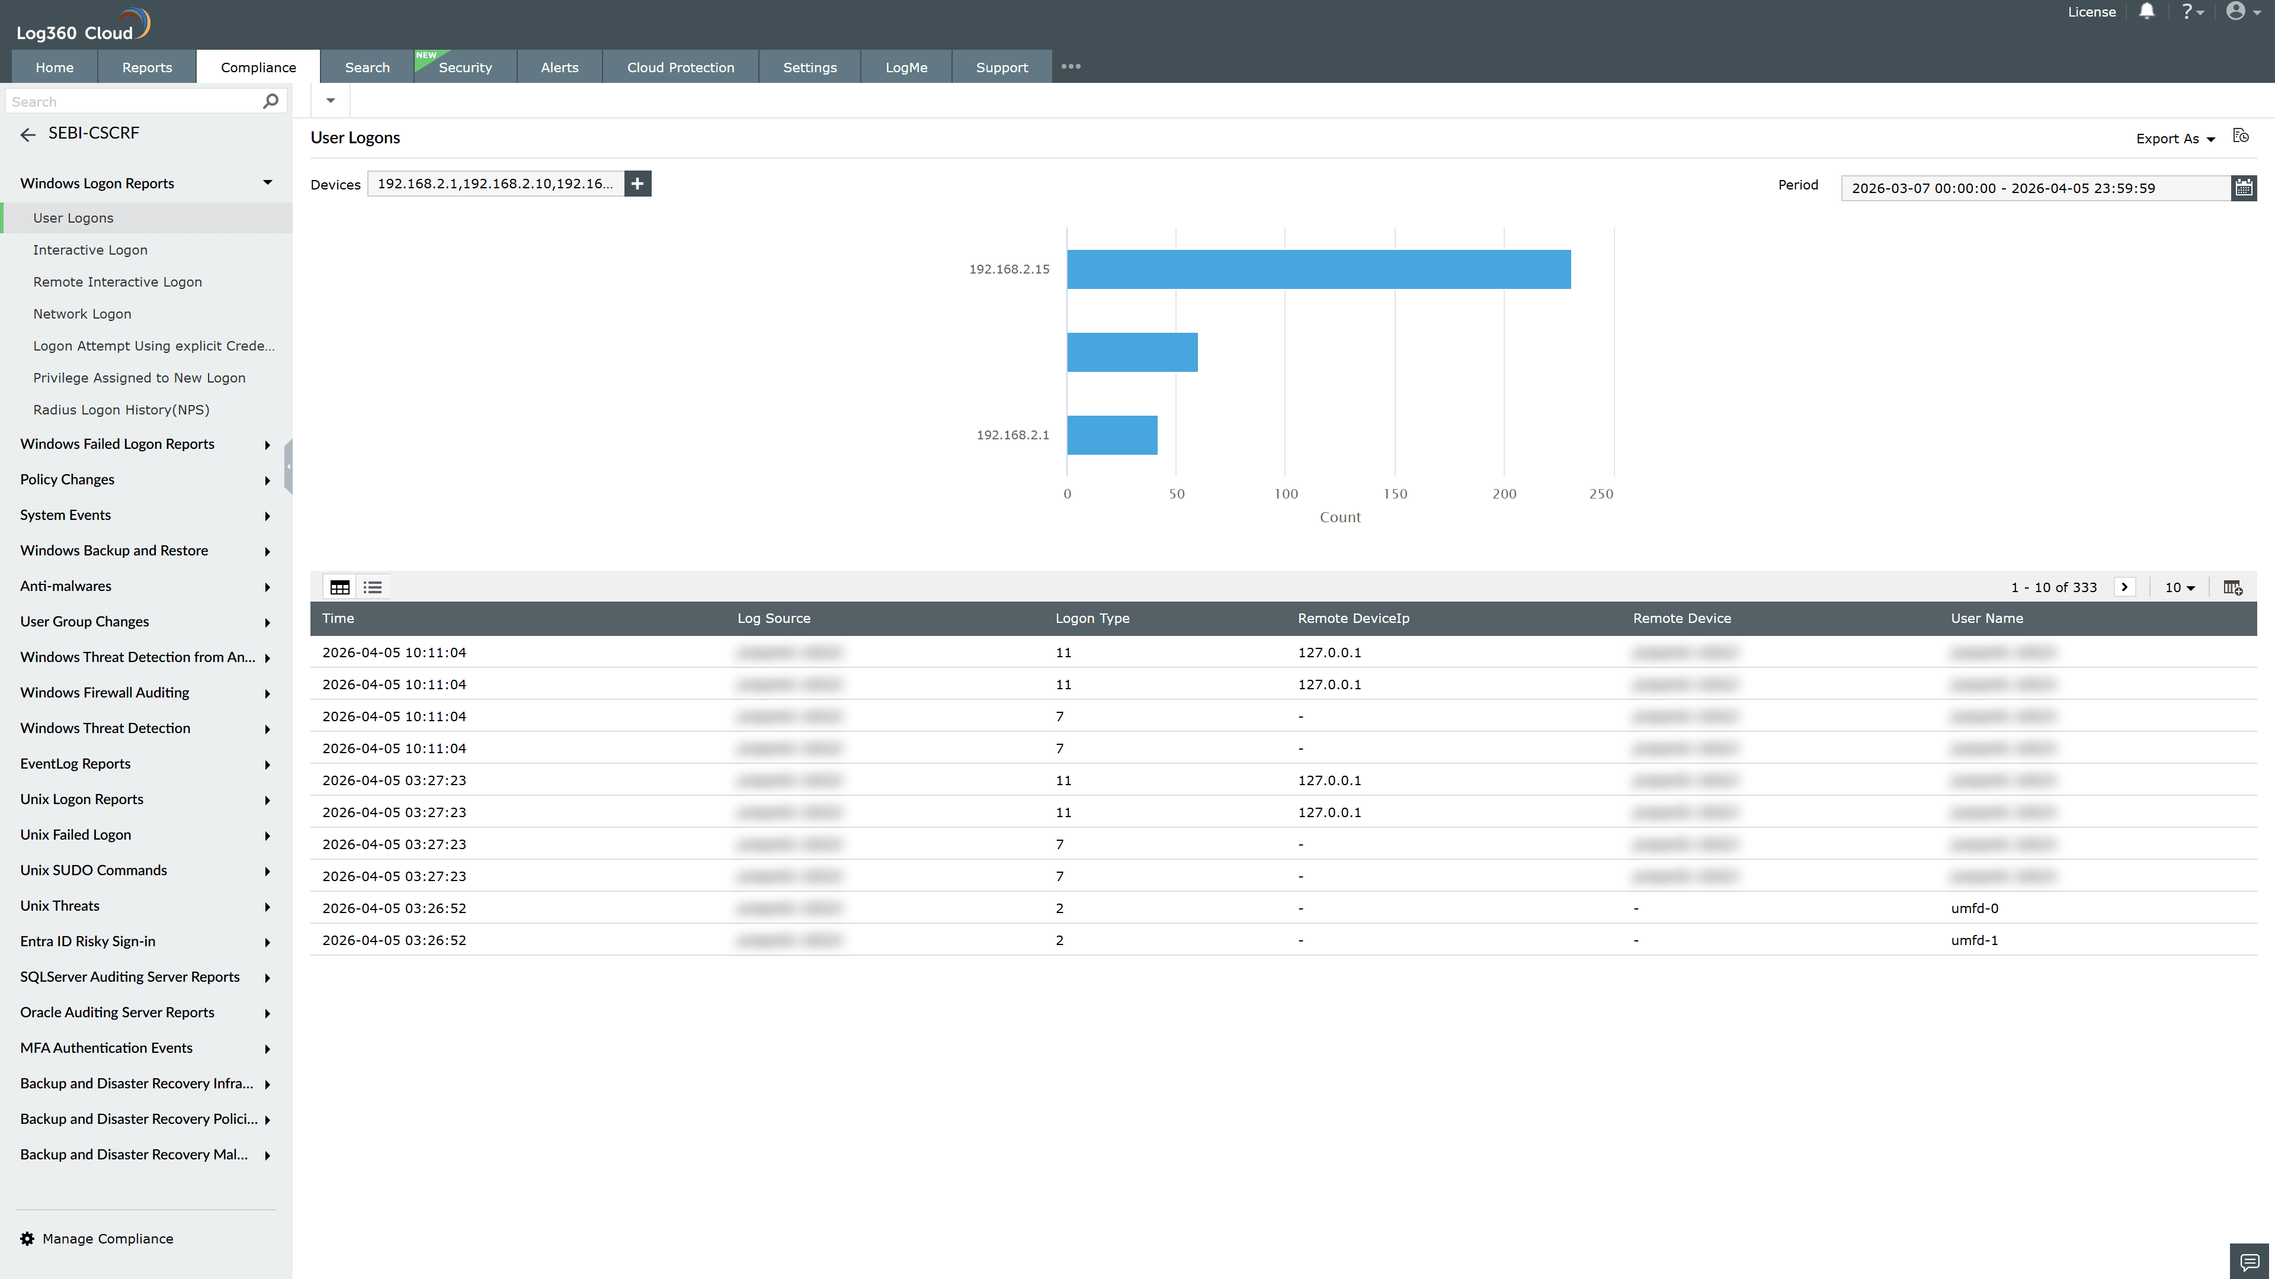
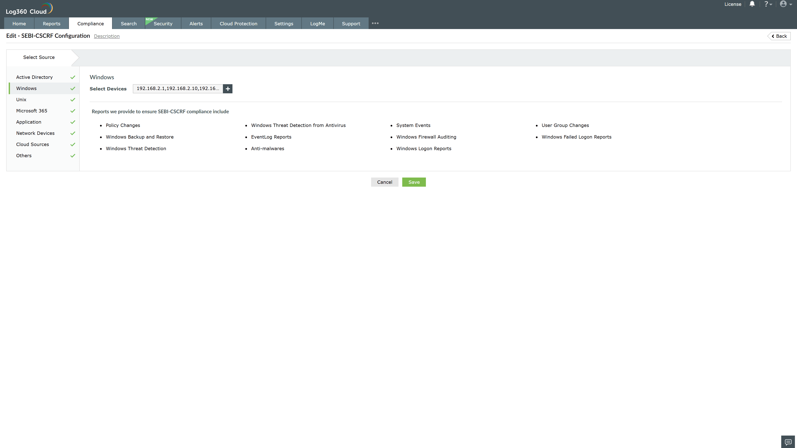
Valid Submission : Yes
Supported Editions : Free, Basic, Standard, Professional, MSSP
Help Document : https://www.manageengine.com/log-management/help/integrations/compliance-extensions.html
Help Video : Not provided
Tags : Log360, Compliance, Privacy monitoring, Data privacy, Regulatory compliance
Supported DCs : US, IN, JP, CA, AU, UK and EU
Privacy Policy:
Terms of Service:
Release Notes:
Predefined reports for the SEBI-CSCRF.

